Assessing Virtualization Software

Daniel R. Cender

Grand Canyon University: CST-221-O500

Feb 23, 2020

This assignment will explore the current state of virtualization software as an industry and will report on the quality of the foremost producers of these products. In particular, these tools will be evaluated on how they might fill the need for access to course-required software tools for academic instructors and students. Using virtualized desktops with pre-installed programs eliminates the hassle of requiring every student to possess a caliber of system they maybe can’t afford. The aim is to discover if the current offerings of virtualized desktops offer the security configurations and power allocations to suit a range of student and faculty needs. Generally speaking, most students would fall into a class of either standard users, needing only a couple virtual CPU cores, around 8 GB RAM, and 100 GB storage, or power users, needing 8-16 GB RAM, 4 to 8 vCPU cores, and 250 GB RAM. While developers running heavy IDEs and video production students running rendering software will be clear power users, many humanities and even other technical sciences only require basic applications.

**Industry Products**

Five vendors discovered to hold significant market share in this sector are: Amazon WorkSpaces by Amazon Web Services, Cisco VXI, SolarWinds, VMware Horizon Cloud, and Red Hat Virtualization (Gilbert, 2020).

**Amazon WorkSpaces**

|  |  |
| --- | --- |
| **Company Name** | Cisco |
| **Product Name** | Cisco VXI with VMware View |
| **Version** | Originally released 2014, no incremental updates however, since its maintained purely in “cloud.” |
| **Most Recent Release Date** | N/A |
| **Performance Metrics** | No research resulted in any third parties reporting performance metrics of any kind. The software client’s speed reflects the user’s internet connection speed, so long as they are not performing more complex work than the tier of virtual desktop they’re using can handle. |
| **Cost** | (In US-EAST-2 region) The tiers most likely to be used by academic users would be Performance (2 vCPU, 4 GiB Memory, 80 GB root storage, and 10 GB user partition for $33/month flat or $7.25/month plus $0.30/hour) and Power (4 vCPU, 16 GiB Memory, 80 GB root storage, and 50 GB user partition for $72/month flat or $9.75/month plus $0.68/hour) (Workspaces, n.d.). If absolutely needed, the most powerful bundle they offer contains 16 virtual CPU cores, 122 GiB of RAM, and 1 8 GiB of video memory for the cost of either $999 monthly, or $66/month plus $11.62 per hour of usage (Workspaces, n.d.). |
| **Disaster Recovery Capabilities** | According to the features list, user data is backed up to AWS S3 storage regularly. It follows that backups would be allowed from those locations. |
| **High Availability** | No benchmarks on availability to be found, but neither were any complaints about up-time issues with the service. |
| **Security** | The security setup for WorkSpaces allows administrators to allow access to their desktops based on user policies in Active Directory or RADIUS, common domain management platforms. Administrators can also delegate certificates to trusted devices, whether a desktop or a mobile device, which can then be allocated access to certain desktop setups (Workspaces, n.d.). From all accounts, the security offerings here hold up to industry standards and allow enough flexibility for even the most complex enterprise environments. |
| **Infrastructure Scaling** | The nature of the service allows administrators to designate the bundle types they’d like to provision for their userbase. |
| **Management Tools and Report Generation** | Management largely abstracted away from administrators, besides picking bundle sizes and number of desktops to allow. Admins can delegate access to certain classes of desktops using any current Active Directory domain setup (Amazon WorkSpaces Review, n.d.). |

**Ratings for AWS WorkSpaces**

|  |  |  |
| --- | --- | --- |
| **Category** | **Score** | **Reason** |
| Performance metrics (based on third party reports) | 4 | Offers a wide variety of performance tiers and limited in responsiveness only by internet latency. |
| Cost (for the system that addresses the specific need you identified) | 3 | Price does not scale well with the increase of performance. Less customization than some admins may prefer for their individual user cases. |
| Disaster recovery capabilities | 2 | Little detail given to this topic in the product descriptions, either by AWS or by reviewers. |
| High availability (based on third party reports | 5 | AWS is highly trusted for reliable up-time and no reviewers mentioned latency issues from the product. |
| Security | 5 | Easy integration with most current enterprise setups using Active Directory or RADIUS (Amazon WorkSpaces Review, n.d.). Grants admins the tools to do their due diligence in practicing domain security. |
| Infrastructure scaling | 5 | Desktop pool is highly scalable for administration, with AWS performing all the automatic scaling of resources for customers. |
| Management tools and report generation | 2 | Mention of central admin console for managing user pool, but no other details were found on how metrics may be available to pool admins. |

Overall, WorkSpaces might be a fantastic tool for academic use cases if the savings on equipment for students and faculty can justify the total cost of allocating a mass pool of desktops.

**Cisco VXI**

|  |  |
| --- | --- |
| **Company Name** | Cisco |
| **Product Name** | Cisco VXI: Desktop Virtualization with VMware |
| **Version** | No mention of versions |
| **Most Recent Release Date** | No mention of versions |
| **Performance Metrics** | No performance metrics available. Particular performance of remote desktops are dependent on the infrastructure and/or on-premise hardware customers purchase and use through Cisco. |
| **Cost** | Cost is either highly subjective or requires paying for expensive user/data migrations, so the pricing is dependent on quotes determined by individual customer needs (Cisco VXI: Desktop Virtualization with VMware, 2016). |
| **Disaster Recovery Capabilities** | No specific recovery architectures mentioned. There is rather a high emphasis on the flexibility of this service. |
| **High Availability** | The availability of a Cisco setup requires maintenance from a firm’s own technology team, with any necessary support from Cisco’s technicians. This could mean that the system may fail if the on-premise team is insufficient to support their organization through any failures 24/7, unlike using hosted services such as AWS WorkSpaces. |
| **Security** | No exact architecture/policy details are disclosed, but the vendor touts the security benefits of using them for end-to-end infrastructure needs. |
| **Infrastructure Scaling** | Adding new users and virtual desktops can be accomplished in minutes, in contrast to potential weeks if acquiring and formatted hardware for new users. |
| **Management Tools and Report Generation** | Cisco grants the customer’s IT team absolute control of infrastructure resources, except where a Cisco-provided virtual data center may be in the stack. They offer a “Cisco Unified Computing System” which helps manage a whole stack of Cisco products that claim to serve all enterprise tech needs. |

**Cisco VXI Ratings**

|  |  |  |
| --- | --- | --- |
| **Category** | **Score** | **Reason** |
| Performance metrics (based on third party reports) | 2 | Offers few details on any performance metrics. |
| Cost (for the system that addresses the specific need you identified) | 1 | No details at all publicly available on what to expect of pricing model. |
| Disaster recovery capabilities | 2 | Little detail or assurance is given to this topic in the product descriptions. |
| High availability (based on third party reports | 2 | Little detail given by vendor or reviewers. |
| Security | 3 | Grants admins the tools to do their due diligence in practicing domain security. Not-so-easy integration with current environments. |
| Infrastructure scaling | 3 | Virtualization pool is highly scalable, if ample infrastructure resources have been allocated and paid for already. |
| Management tools and report generation | 2 | Key centralized tools available for admins, but with the assumption that all infrastructure and user management is held in Cisco’s product sphere. |

The document surrounding this product leaves a lot of detail to be desired. Perhaps this would be a great tool for communication-heavy departments or companies, but it would be ill-suited for an academic institution most likely.

**SolarWinds Virtualization Manager**

|  |  |
| --- | --- |
| **Company Name** | SolarWinds |
| **Product Name** | Virtualization Manager |
| **Version** | N/A |
| **Most Recent Release Date** | N/A |
| **Performance Metrics** | Highly scalable in performance, letting administrators tether the manager to virtualization setups on owned hardware or container instances in AWS EC2 or Microsoft Azure VM. Easily integrates with whatever tier customers prefer to use, so performance is bound to those cloud hosted offerings. |
| **Cost** | Vendor baselines the cost at $3,085, presumably with usage unit costs tacked onto that past a certain limit. |
| **Disaster Recovery Capabilities** | No disaster recovery abilities. |
| **High Availability** | Dependent on the availability on either on-premise or cloud-hosted VMs. |
| **Security** | No key emphasis or comments on security from vendor or reviews. |
| **Infrastructure Scaling** | This does not automatically handle scalability for virtual machines. Part of its feature set is to kill off orphaned VMs and virtualized process to free up resources in the pool so there is no unnecessary scaling up in resources, which cause waste in consumption fees from cloud hosts. |
| **Management Tools and Report Generation** | This tool is a one-stop shop for manageing pools of VMs and viewing customizable metrics on performance and availability. |

**SolarWinds Virtualization Manager Ratings**

|  |  |  |
| --- | --- | --- |
| **Category** | **Score** | **Reason** |
| Performance metrics (based on third party reports) | 5 | Offers much detail on various performance metrics. |
| Cost (for the system that addresses the specific need you identified) | 2 | Some baseline cost data publicly available, but otherwise is pretty obscured for heavier customer needs. |
| Disaster recovery capabilities | 1 | No details or mention of data recovery by vendor or reviews. |
| High availability (based on third party reports | 3 | Highly dependent on what cloud host is integrated or if the on-premise team managing physical infrastructure is competent. |
| Security | 1 | No mention as to security for this. |
| Infrastructure scaling | 2 | Assumed that integrating with EC2 or Azure VM uses their scalable nature, but this product mainly focuses on decreases unnecessary use, not increasing upward scalability. |
| Management tools and report generation | 5 | VM management and reporting is the bread-and-butter feature set of this product. |

If the technology team behind a school were capable to configure a pool of resources through a cloud host or on-premise, this could be a useful tool for helping them manage a highly configurable environment. A key benefit would be escaping “vendor lock-in” to a fully hosted virtualization service like AWS WorkSpaces.

**VMware Horizon Cloud**

|  |  |
| --- | --- |
| **Company Name** | VMware |
| **Product Name** | Horizon Cloud |
| **Version** | N/A |
| **Most Recent Release Date** | N/A |
| **Performance Metrics** | There were no details on exact performance metrics. |
| **Cost** | Pricing is formatted in the subscription model, where customers pay every month per user or workstation they add. Pricing starts (depending on specific hosting details) at around $16.50 per unit every month. Higher capacity workstations can cost as much as $300 per unit each month, so there is a range of flexibility. |
| **Disaster Recovery Capabilities** | No mention of disaster recovery techniques. |
| **High Availability** | This product boasts a 99.99% availability. It is the only product in this list that has listed any concrete numbers concerning availability. |
| **Security** | Security is not discussed. |
| **Infrastructure Scaling** | Since the infrastructure is hosted and managed automatically by VMware’s services and technicians, the infrastructure is highly scalable overall. |
| **Management Tools and Report Generation** | There are central unified management pages for use by pool administrators |

**VMware Horizon Cloud Ratings**

|  |  |  |
| --- | --- | --- |
| **Category** | **Score** | **Reason** |
| Performance metrics (based on third party reports) | 2 | There are very few details about performance of VMs. |
| Cost (for the system that addresses the specific need you identified) | 4 | The data shown around cost is the most transparent besides AWS WorkSpaces. There’s a clear price breakdown for monthly usage cases. |
| Disaster recovery capabilities | 1 | No details or mention of data recovery by vendor or reviews. |
| High availability (based on third party reports | 3 | Highly dependent on what cloud host is integrated or if the on-premise team managing physical infrastructure is competent. |
| Security | 1 | No mention as to security for this. |
| Infrastructure scaling | 4 | Cloud-hosted infrastructure is fine-tuned by VMware’s services to provide the scale needed by every customer. |
| Management tools and report generation | 5 | VM management and reporting is the bread-and-butter feature set of this product. |

**Citrix Virtual Apps & Desktops**

|  |  |
| --- | --- |
| **Company Name** | Citrix |
| **Product Name** | Virtual Apps & Services |
| **Version** | N/A |
| **Most Recent Release Date** | N/A |
| **Performance Metrics** | Highly customizable here for graphics-heavy user scenarios. |
| **Cost** | The data shown around cost is as transparent as VMware’s. Price is per-license. |
| **Disaster Recovery Capabilities** | No mention. |
| **High Availability** | No mention. |
| **Security** | Little mention. |
| **Infrastructure Scaling** | Also little mention. |
| **Management Tools and Report Generation** | Simple management portal offered for user/desktop tweaking. |

**Citrix Virtual Apps & Desktops Ratings**

|  |  |  |
| --- | --- | --- |
| **Category** | **Score** | **Reason** |
| Performance metrics (based on third party reports) | 2 | No specific details broken down in descriptions, but reviews praised the product’s support for high-end graphics card acceleration. |
| Cost (for the system that addresses the specific need you identified) | 5 | Price breakdown makes yearly billing easier to calculate in advance. |
| Disaster recovery capabilities | 1 | No details or mention of data recovery by vendor or reviews. |
| High availability (based on third party reports | 3 | Highly dependent on what cloud host is integrated or if the on-premise team managing physical infrastructure is competent. |
| Security | 3 | Works especially to filter web traffic out of secured company domains while still giving users delegated access to needed company data. |
| Infrastructure scaling | 1 | No mention as to how capable Citrix is at scaling. |
| Management tools and report generation | 4 | Review praised the simple, single management console. |

**Conclusion**

Much of the desktop virtualization software and hosting on the market right now obscures many of the fine details and specifications from view until the potential customer connects with official vendor salespeople. This obscures the results of this research assignment greatly, while also illustrating the current state of this sector of technology. Amazon Web Services largely tends to be the most forthright with their pricing and specification details. They also happen to be the largest cloud provider in North America, as well as many other parts of the world.

Figure 1 illustrates how a common virtualized desktop environment may look using a hosted service like AWS WorkSpaces. No hardware is managed, and all domain security delegation is handled through Active Directory security groups.

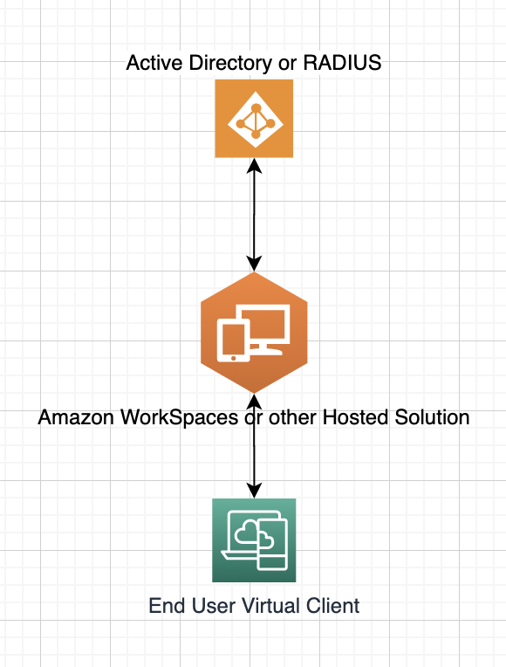

*Figure 1.* Virtual Desktops using hosted solution.

Figure 2 illustrates, highly simplified, how hardware and infrastructure are managed manually as part of the overall computing stack.

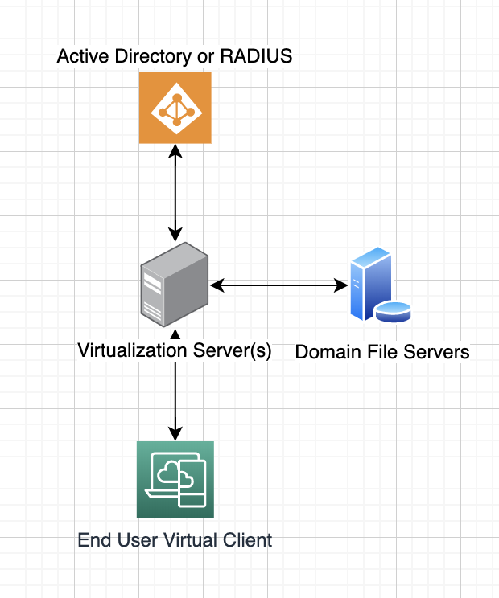

*Figure 2.* Diagram showing hardware used in end-to-end desktop virtualization.

**Application**

**VT-Enabled CPU Vs Translation Software**

It’s difficult to measure the performance of virtualized operating systems on VT-enabled CPU architectures against that of running OS processes in translation software. There are some key security benefits in running processes in a translation layer, since they do not necessarily get access to all host OS features. Portability, or compatibly running otherwise-incompatible programs side-by-side, is an added benefit of software translation virtualization. A tool like *Wine* can allow Windows programs to be run virtually almost perfectly on a Linux desktop or server. A tool that uses this model is Citrix XenApp, which is offered alongside Citrix’s other full desktop solutions.

There is much speed to be gained from running an application against a virtual environment (usually comprised of one file) instead of natively, where it may need access (which will need to be checked consistently by the OS) to many files distributed across disks and shards in those disks. Since a software virtualization solution uses less resources than a full virtualized desktop, it becomes more performant with the same quality and quantity of resources being poured into it. In some cases, application streaming occurs as an implementation of this. Only crucial bits of the process and transferred/translated and run initially to start the virtualization, then the rest of the program is streamed in using a network protocol over time as needed.

**Translated Code Versus Original Code**

In a translated code virtualization solution, all software instructions are evaluated for any “unsafe” operations by a binary translator. If that binary translator discovers any instructions it deems unsafe to run directly on hardware, it will translate it into an instruction set to run against the virtualized hardware system. In this way, many calls that would otherwise trap to the operating system and require expensive trap handling processes are avoided (Gelas, 2008). This binary translation and “safer” code execution process ends up saving much precious time and overhead processing power by executing a higher percentage of instructions in the user space than a completely native system. This reality lends itself to why translation software (mentioned above) can run programs effectively, and sometimes, faster than when they run natively on a system.

It sounds like most virtualization solutions today, especially those using proprietary technology from VMware, integrate this technique for offsetting any other latency or performance issues with virtualized desktops (Gelas, 2008). Part of VMware’s binary translator’s speed comes from how they wrote it as an x86 to x86 translator, whereas other solutions at the time, and some that came afterwards, were attempting to translate from one instruction set architecture to another (x86 to IA64, x86 to LVIW, etc.). VMware’s solution also utilizes a Translator cache and Trace cache, which records the program’s control flow. This cache allows the translation process to decrease in overhead processing cost as the program executes.

References

Amazon WorkSpaces Review. (n.d.). Retrieved February 23, 2020, from https://reviews.financesonline.com/p/amazon-workspaces/

Best Virtualization Software Comparison in 2020. (2019, December 13). Retrieved February 23, 2020, from <https://www.dnsstuff.com/virtualization-software>

Choosing A Computer for Video Editing. (n.d.). Retrieved February 23, 2020, from <https://www.desktop-documentaries.com/computer-for-video-editing.html>

Cisco VXI: Desktop Virtualization with VMware. (2016, September 30). Retrieved February 23, 2020, from <https://www.cisco.com/c/en_au/solutions/data-center-virtualization/desktop-virtualization/vmware.html#~architecture>

Gelas, J. D. (2008, March 17). Hardware Virtualization: the Nuts and Bolts. Retrieved February 23, 2020, from https://www.anandtech.com/show/2480/4

Gilbert, N. (2020, January 22). What is the best virtual desktop infrastructure software in 2020? The best virtual desktop infrastructure soft. Retrieved February 23, 2020, from https://financesonline.com/virtual-desktop-infrastructure/

The 2020 State of Virtualization Technology. (n.d.). Retrieved February 23, 2020, from <https://www.spiceworks.com/marketing/reports/state-of-virtualization/>

Workspaces. (n.d.). Retrieved February 23, 2020, from https://aws.amazon.com/workspaces/features/?nc=sn&loc=2